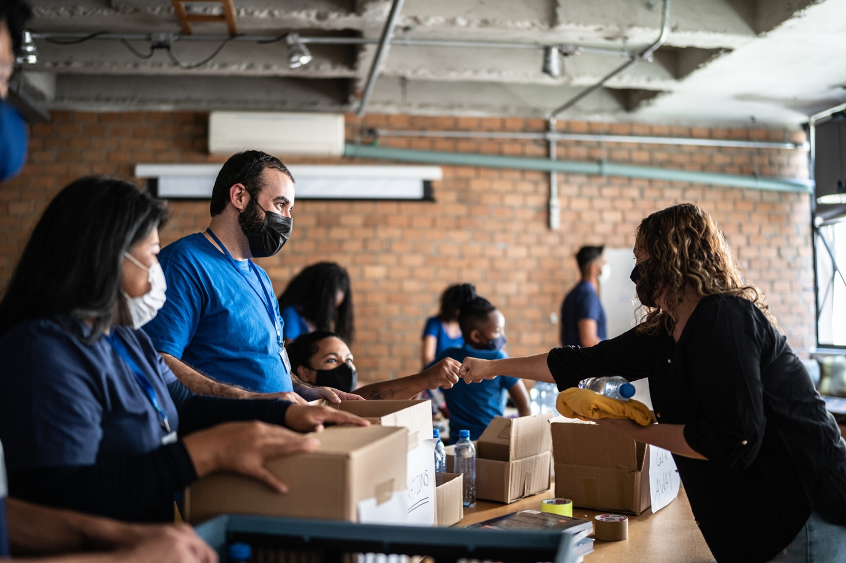

Making human rights real in a disaster
  - Checklist for integrating human rights during relief and recovery efforts
March 2023

Foreword
Human rights gain in importance during relief and recovery efforts as they can safeguard the dignity of those affected.
We know from experience, including from the Canterbury earthquakes, that ensuring a human rights-based approach to responding to disasters and emergencies is critical to protecting the most vulnerable in our communities.

Disaster response efforts must be guided by the principles of non-discrimination, participation and inclusion, accountability and transparency, respect for dignity and privacy, protection of vulnerable groups, and access to justice.

This checklist aims to help busy local and national officials, and others, apply human rights and te Tiriti o Waitangi in their vital relief and recovery efforts.

Human rights and te Tiriti can help all of us support and deliver for everyone affected by a disaster.

Paul Hunt
Chief Human Rights Commissioner

Introduction
The purpose of this checklist is to provide government agencies, officials, and organisations involved in the emergency response to natural disasters, emergencies and adverse climate related events with guidance regarding key human rights issues and potential violations during response, recovery and preparedness activities.

It is also useful for affected persons to see themselves as rights-holders, as opposed to passive beneficiaries of charity and to ensure they can hold duty-bearers, like local and central government agencies or in some circumstances businesses, to account.

This document begins by providing general guidance on the obligations of the state during a disaster. Following this, it provides a list of questions for duty bearers to consider prior, in response and when recovering to a disaster. However, this document is not an exhaustive list of human rights considerations but rather a starting point to understand how to integrate human rights during response, relief and recovery efforts.

General guidance
Natural disasters, emergencies and climate change threaten the effective enjoyment of all human rights, including the right to life, the right to adequate food, the rights to health care and public health, the right to adequate housing, the right to self- determination, the right to safe drinking water and sanitation, and Indigenous Peoples’ rights to their lands, territories and natural resources.

States have a human rights obligation to prevent the foreseeable adverse effects of climate change and to ensure that those affected by it, particularly those in vulnerable situations, have access to effective remedies and means of adaptation to enjoy lives of human dignity.

Human rights are the legal underpinning of all humanitarian work pertaining to natural disasters. During relief and recovery efforts the protection of human rights gains in importance as it can safeguard the dignity of those affected. It is therefore essential that during times of disaster, emergencies and climate related events that human rights are upheld and the needs of the most vulnerable are prioritised.

A human rights approach should underpin disaster management, before, during and after the event. It bases actions within a framework of agreed universal human rights principles, such as dignity, non-discrimination, participation, protection of vulnerable groups and accountability. It also reaffirms obligations to Tangata Whenua under Te Tiriti o Waitangi.

A human rights approach grounded in Te Tiriti o Waitangi addresses fundamental human rights through the perspective of the articles of Te Tiriti o Waitangi. This means recognising and enabling the exercise of tino rangatiratanga and self- determination of Tangata Whenua, ensuring their participation in decision-making and equitable resourcing. In practice, the exercise of tino rangatiratanga, self-determination and manaakitanga has been seen in the swift and effective response of iwi, hapū, marae and Māori organisations in numerous emergency situations, including the Christchurch earthquakes, Covid-19 response and Cyclone Gabrielle.

Checklist

The checklist is separated into three sections: readiness, response and recovery. Readiness deals with activities that happen prior, response refers to activities in the immediate aftermath and recovery refers to the medium to long term response to a natural disaster. It is not an exhaustive list of all human rights issues which may emerge, nor are all issues relevant in all contexts.

Readiness

- Is all information about what to do in an emergency available, understandable and accessible to all communities?
- Are systems and processes in place for a coordinated response that protects people’s human rights and upholds Te Tiriti obligations?
- Do officials and response personnel understand the role of human rights in a disaster?
- Are there national disaster management plans with a human rights and Te Tiriti approach integrated through-out?
- Are there early warning systems which cater to vulnerable communities?
- Are Tangata Whenua including marae, hapū, iwi, and other Māori organisations equitably resourced alongside other responders?
- Do basic services providers have contingency plans to ensure sufficient continuity of services in the event of a disaster?
- Is there an independent dispute resolution mechanism ready for when issues arise during a disaster? For instance, is there a mechanism for raising issues related to compensation, participation and discrimination.
- Are there clear policies, processes and criteria for issuing compensation and insurance?

Response
- Have all people been provided with accurate, understandable and accessible information regarding the scale of the disaster, potential secondary hazards and ongoing humanitarian assistance, such as cash or in-kind assistance.
- Do all people have unrestricted and non-discriminatory access to goods and services to address their basic needs such as water, food, health care, education and employment to ensure vulnerable groups and individuals are not further disadvantaged?
- Are links to whānau and communities being maintained and protected? For instance, have members of displaced families who wish to remain together been given the opportunity to do so?
- Are goods and services provided and managed in a way that considers the safety, and preserves the dignity, of vulnerable groups
- Are recovery activities and measures culturally acceptable and appropriate to the needs of the affected population?
- Do humanitarian, Tangata Whenua and community groups providing emergency response services have appropriate access to all affected areas and populations?
- Is there a need for trauma counselling and is it available?
- Are steps being taken to prevent spread of infectious disease or minimise exposure to the most vulnerable populations?

Recovery
- Are those directly affected by a disaster involved, informed, empowered and able to fully participate in decision-making which affects them? For instance, have all members of the affected population been meaningfully consulted and, where possible, involved in the planning, implementation, and monitoring of response and recovery programmes?
- When rights need to be balanced, is this being done in a way that ensures decisions are in-line with international human rights standards and te Tiriti o Waitangi, and the needs of the most vulnerable people are being prioritised?
- Has the return of housing, land, property and possessions to the affected population been facilitated by the authorities as soon as possible and have people been properly informed and consulted?
- Is temporary shelter being provided and has accessibility, affordability, habitability, safety standards, security of tenure, cultural adequacy, suitability of location, access to essential services been considered?
- Are people able to resume their livelihoods, identify new employment opportunities or access programmes that support them to restore their economic security?
- Is there access to independent process if an individual or community believes compensation is unfair? For instance, can those affected complain about decisions that affect them and have their complaints about decisions or matters affecting them resolved in a timely and effective manner?
- Has a clear plan for compensation including fair objective criteria been developed and communicated to people, and is compensation being disbursed in a timely, non- discriminatory manner?
- Are the human rights of people affected being monitored to ensure their rights are given effect, and is that monitoring being used to hold duty bearers accountable?
- Are procedures in place to assist those who have lost legal documents and identification?
- Is all this information available in appropriate languages and accessible formats to ensure it reaches everyone in the community?
- Are disaster recovery efforts prioritising long-term recovery and sustainability, including addressing underlying vulnerabilities and promoting Te Tiriti- and human rights-based development?
- Have tikanga and cultural traditions, including for example burials, rāhui and re-accessing land following disasters received due attention in the planning and implementation of the recovery programme?

Glossary

Duty bearers
Duty-bearers are those actors who have a particular obligation or responsibility to respect, promote and realise human rights and to abstain from human rights violations. The term is most used to refer to State actors, but non-State actors such as business are also duty-bearers.

Rights-holders
Rights-holders are individuals or social groups that have entitlements in relation to specific duty-bearers. In general terms, all human beings are rights-holders under the International Bill of Human Rights.

As emphasised by the United Nations Human Rights Council (UNHRC) in a 2011 resolution: “climate change-related impacts have a range of implications, both direct and indirect, for the effective enjoyment of human rights.” UNHRC ‘Human rights and climate change’ (26 September 2011, A/HRC/18/L.26) at Preamble. See also UN Office of the High Commissioner on Human Rights (OHCHR) Statement of the United Nations Special Procedures Mandate Holders on the occasion of the Human Rights Day Geneva (10 December 2014).
The concept of dignity is a core feature underpinning all human rights. See for example, Preamble, Universal Declaration of Human Rights Recognition of the inherent dignity and of the equal and inalienable rights of all members of the human family is the foundation of freedom, justice and peace in the world.
The IASC Operational Guidelines on Human Rights and Natural Disasters provides more details on the legal aspects of humanitarian work.
United Nations, Sendai Framework on Disaster Risk Reduction 2015-2030, Part III: Guiding Principles, p 13, paragraphs 19(c) and 19(d).
The International Bill of Human Rights refers to the Universal Declaration of Human Rights, International Covenant on Civil and Political Rights, and International Covenant on Economic, Social and Cultural Rights. New Zealand has affirmed the Universal Declaration and ratified both International Covenants

